**Front-side of Story Card**

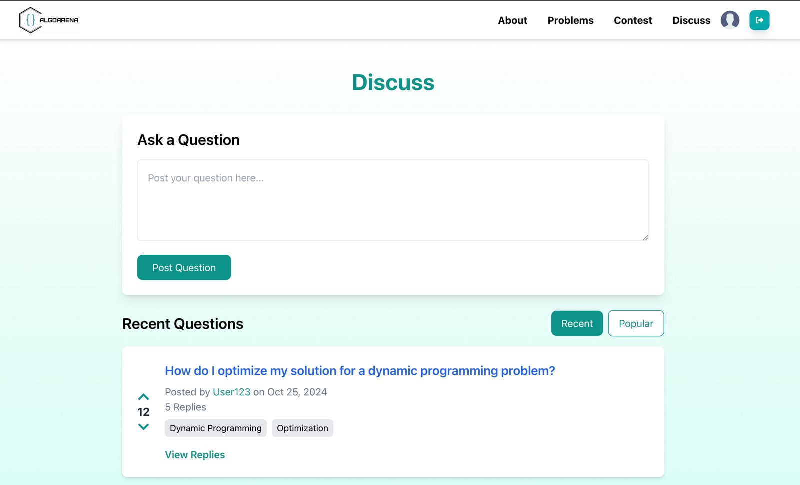

**As a** user,  
**I want to** participate in discussion forums,  
**So that** I can collaborate with other participants.

**Backside of the story card**

| Success Conditions   * Users can create, reply to, and edit posts. * Forums display posts by category and topic.   Failure Conditions   * Posts fail to save or display incorrectly. * Forum categories are missing or broken. |
| --- |